Observations/Suggestions of the external NBA expert Prof (Dr.) Swapan Kumar Goswami, JU, during NBA awareness program of the Dept. of EE held on 03.01.2020 in the Institute Language Laboratory
- At present EE program is suitable for application and extension of Provisional Accreditation (for 03 yrs).
- Alumina feedback and feedback from the stake holders are essential for defining the Mission Visions and PEOs of the Department.
- It is required to take student feedbacks in each subject for the formation and mapping of COs. In each subject, 5-6 nos of COs are sufficient. More numbers of COs make the process complicated and cerate difficulty to frame questions for the students in the internal examinations.
- To calculate CO and PO attainment some procedures/measures to be taken for the consideration of university semester marks as it has more weightage (70 %) of the total marks, assuming university considers the entire COs for framing of semester question papers. A committee can be made to supervise the overall attainment.
- There should be some process to identify/handle week and bright students. Necessary steps to be taken to guide weak students and encourage bright students. Innovative Project should be assigned for the bright students and some token awards may be given to them. Some special lecture class can be arranged for the week students.
- During Curriculum Gap analysis, it is not essential to follow exactly the AICTE model Syllabus for the preparation of compliance report. The Curriculum Gap can be analyzed jointly by the subject teacher and the Academic committee of the Department so that all the POs can be covered. The identified curriculum gap should be communicated to the affiliating university for the necessary actions taken in this matter.
- To enhance industry institute interaction, Industry expert can be called for 4th Year Project viva voce examination and also industry experts can be invited for the Student Programs/Events. More experts from the industry to be kept in the different committee of the Institute.
- Innovative idea in Teaching Learning Process may be given to the Institute website. In this regard model/prototype presentation and demonstration can be arranged for the students. All the innovative project works should be displayed in the Dept.
- It is required to enhance the activities of the IIPC cell and EDC cell on regular basis.
- All the Laboratories of the EE Dept. have good infrastructures. However, it is pointed out that except Machine-I & II Labs almost all Labs have inadequate space for a batch of 30-35 students. Some defects of civil works in the Lab and class rooms have been observed.
- HOD, EE Room out-fit should be better for overall impression though it does not carry any marks in NBA.
- Academic Audit is required at least once in a year and report to be given in website.
- Institute authority also should take initiative for Budget allocation and utilization for the Departmental requirements to fill the gap between the actual expenses and the approved Budget.
- All BOM & BOG minutes should be available in the Institute Website.

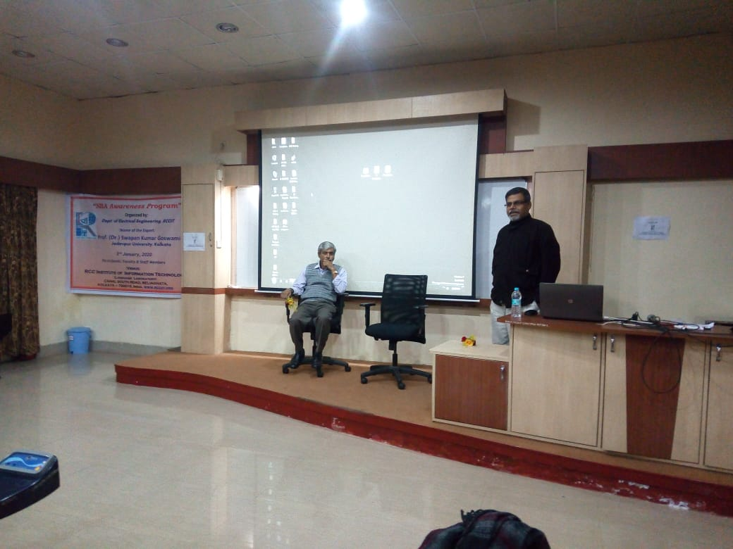

Inauguration speech by Prof (Dr.) Arup Kumar Bhaumik, Principal, RCCIIT in the EE Department NBA Awareness program

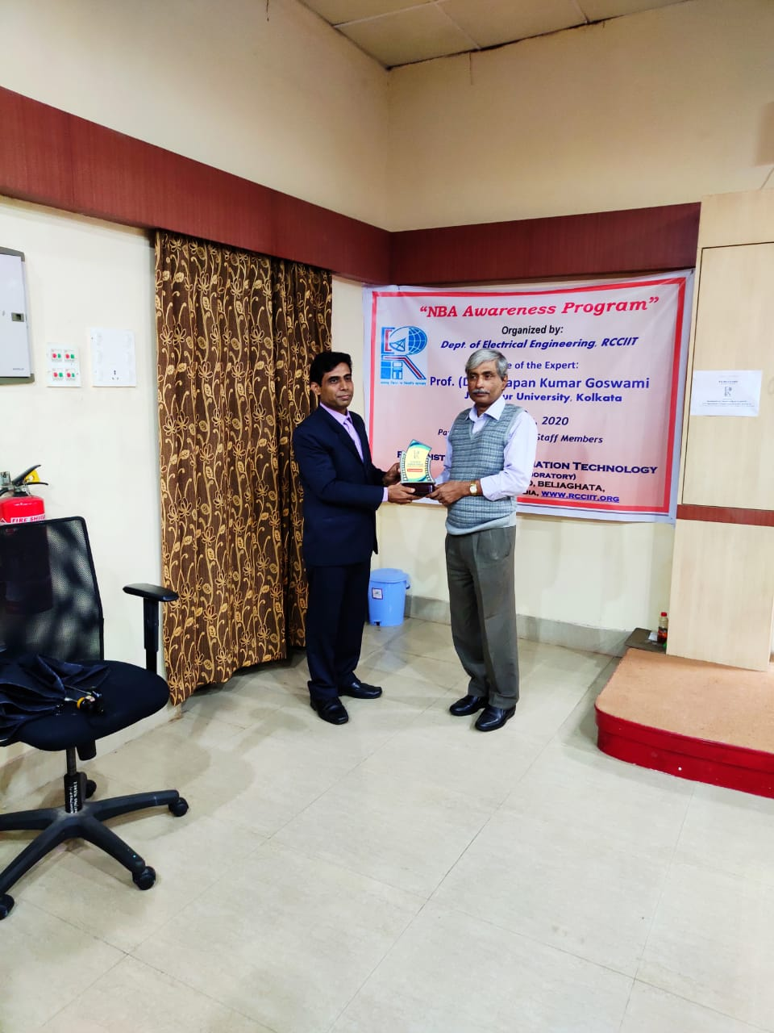

Presentation of Memento to Prof. (Dr.) Swapan Kumar Goswami by HOD, EE

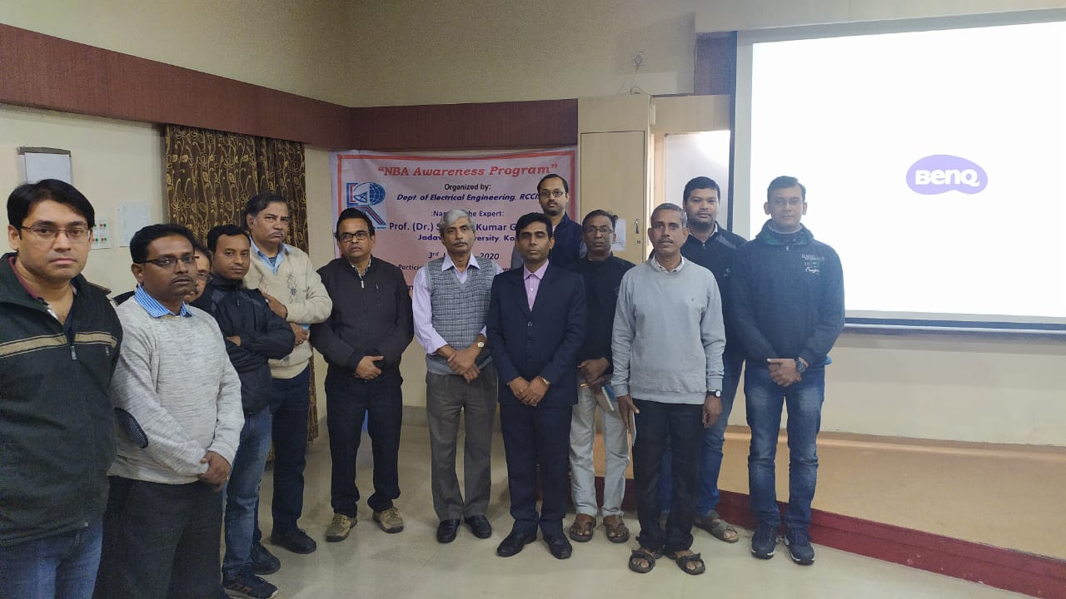
Faculty and staff members of the EE Dept. with Prof. (Dr.) Swapan Kumar Goswami

